Media Release: Immediate
PMC making everyday a Mandela Day!
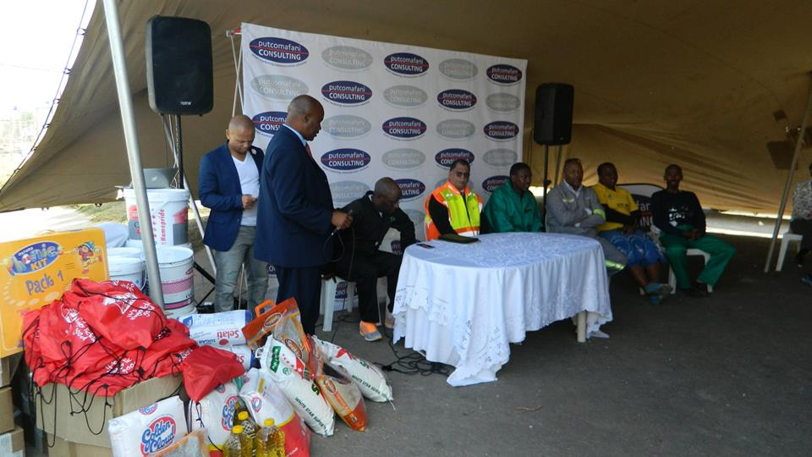
Stakeholders of putcomafani CONSULTING

On Friday the 15th of July, putcomafani CONSULTING (PMC) focused its philanthropic lenses this Mandela Month on the Thamsanqa Project, a non-profit making organisation (NPO) in Motherwell with 4 homes housing 49 disadvantaged children ranging from age 3-17years. PMC heeded the global call to honour the late world leader Tata Nelson Mandela; Mandela Day is a global call to action that celebrates the idea that each individual has the power to transform the world, the ability to make an impact.
Nelson Mandela Bay (NMB) Executive Mayor Danny Jordaan said to the Motherwell residents that “public & private partnerships are important, getting community involvement and corporates to go beyond making a profit”. He continued by saying “dealing with people is as important as making profits, what we see today is wonderful, look at this wonderful house beautifully painted, garden developed is what a living environment should be”. Jordaan further on thanked Putco Mafani for bringing all the sectors and everyone together for such a great initiative.
Putco Mafani the Chief Executive Officer (CEO) at PMC shared that “I am so elated to have been part of a team that organised this event”. Mafani continued by saying “As South Africans we must keep the spirit of Ubuntu alive by always lending a helping hand to those that are less fortunate”.
Louise Fourie founder of the Thamsanqa Project expressed how blessed they feel as they have a deep passion for children and believe that children are gifts from the Lord thus they should have a life of laughter and joy.
PMC along with the Department of Rural Development & Agriculture, Vantyi and Vantyi Funerals, KFC, Coega donated the following items:
- Schooling and Reading Books from the Oxford University Press
- A container that will be converted, modified and customised into a mini library
- Backpacks with goodies from KFC
- 50 blankets from SASSA
- Toiletries from OH SO Heavenly
- Painting material from Sizwe Paints and Plascon
- Gardening tools, seeds, seedlings and Jojo tanks
- Grocery Voucher from Vantyi and Vantyi
- Blankets and Mattresses from Coega
- A tent from Ezamantlane Hiring Services

This Corporate Social Investment (CSI) initiative forms part of the robust community development portfolio PMC embarks on annually along with the Corporate Charity Golf Day and the Cancer Charity Breakfast which have been a resounding success since their inception and have assisted those that are less fortunate.

The programme for the day featured an address by the Executive Mayor and a handover by a representative from the Department of Rural Development & Agriculture and messages of support from the different organisations who have pledged their support.
To end off the festivities of the day, there was a tour of the 4 homes around Motherwell which culminated into a painting and gardening session to beautify one of the Havens for the future leaders of South Africa.

