Media Release: Immediate

Konwaba Training Solutions: Officially opens its doors
f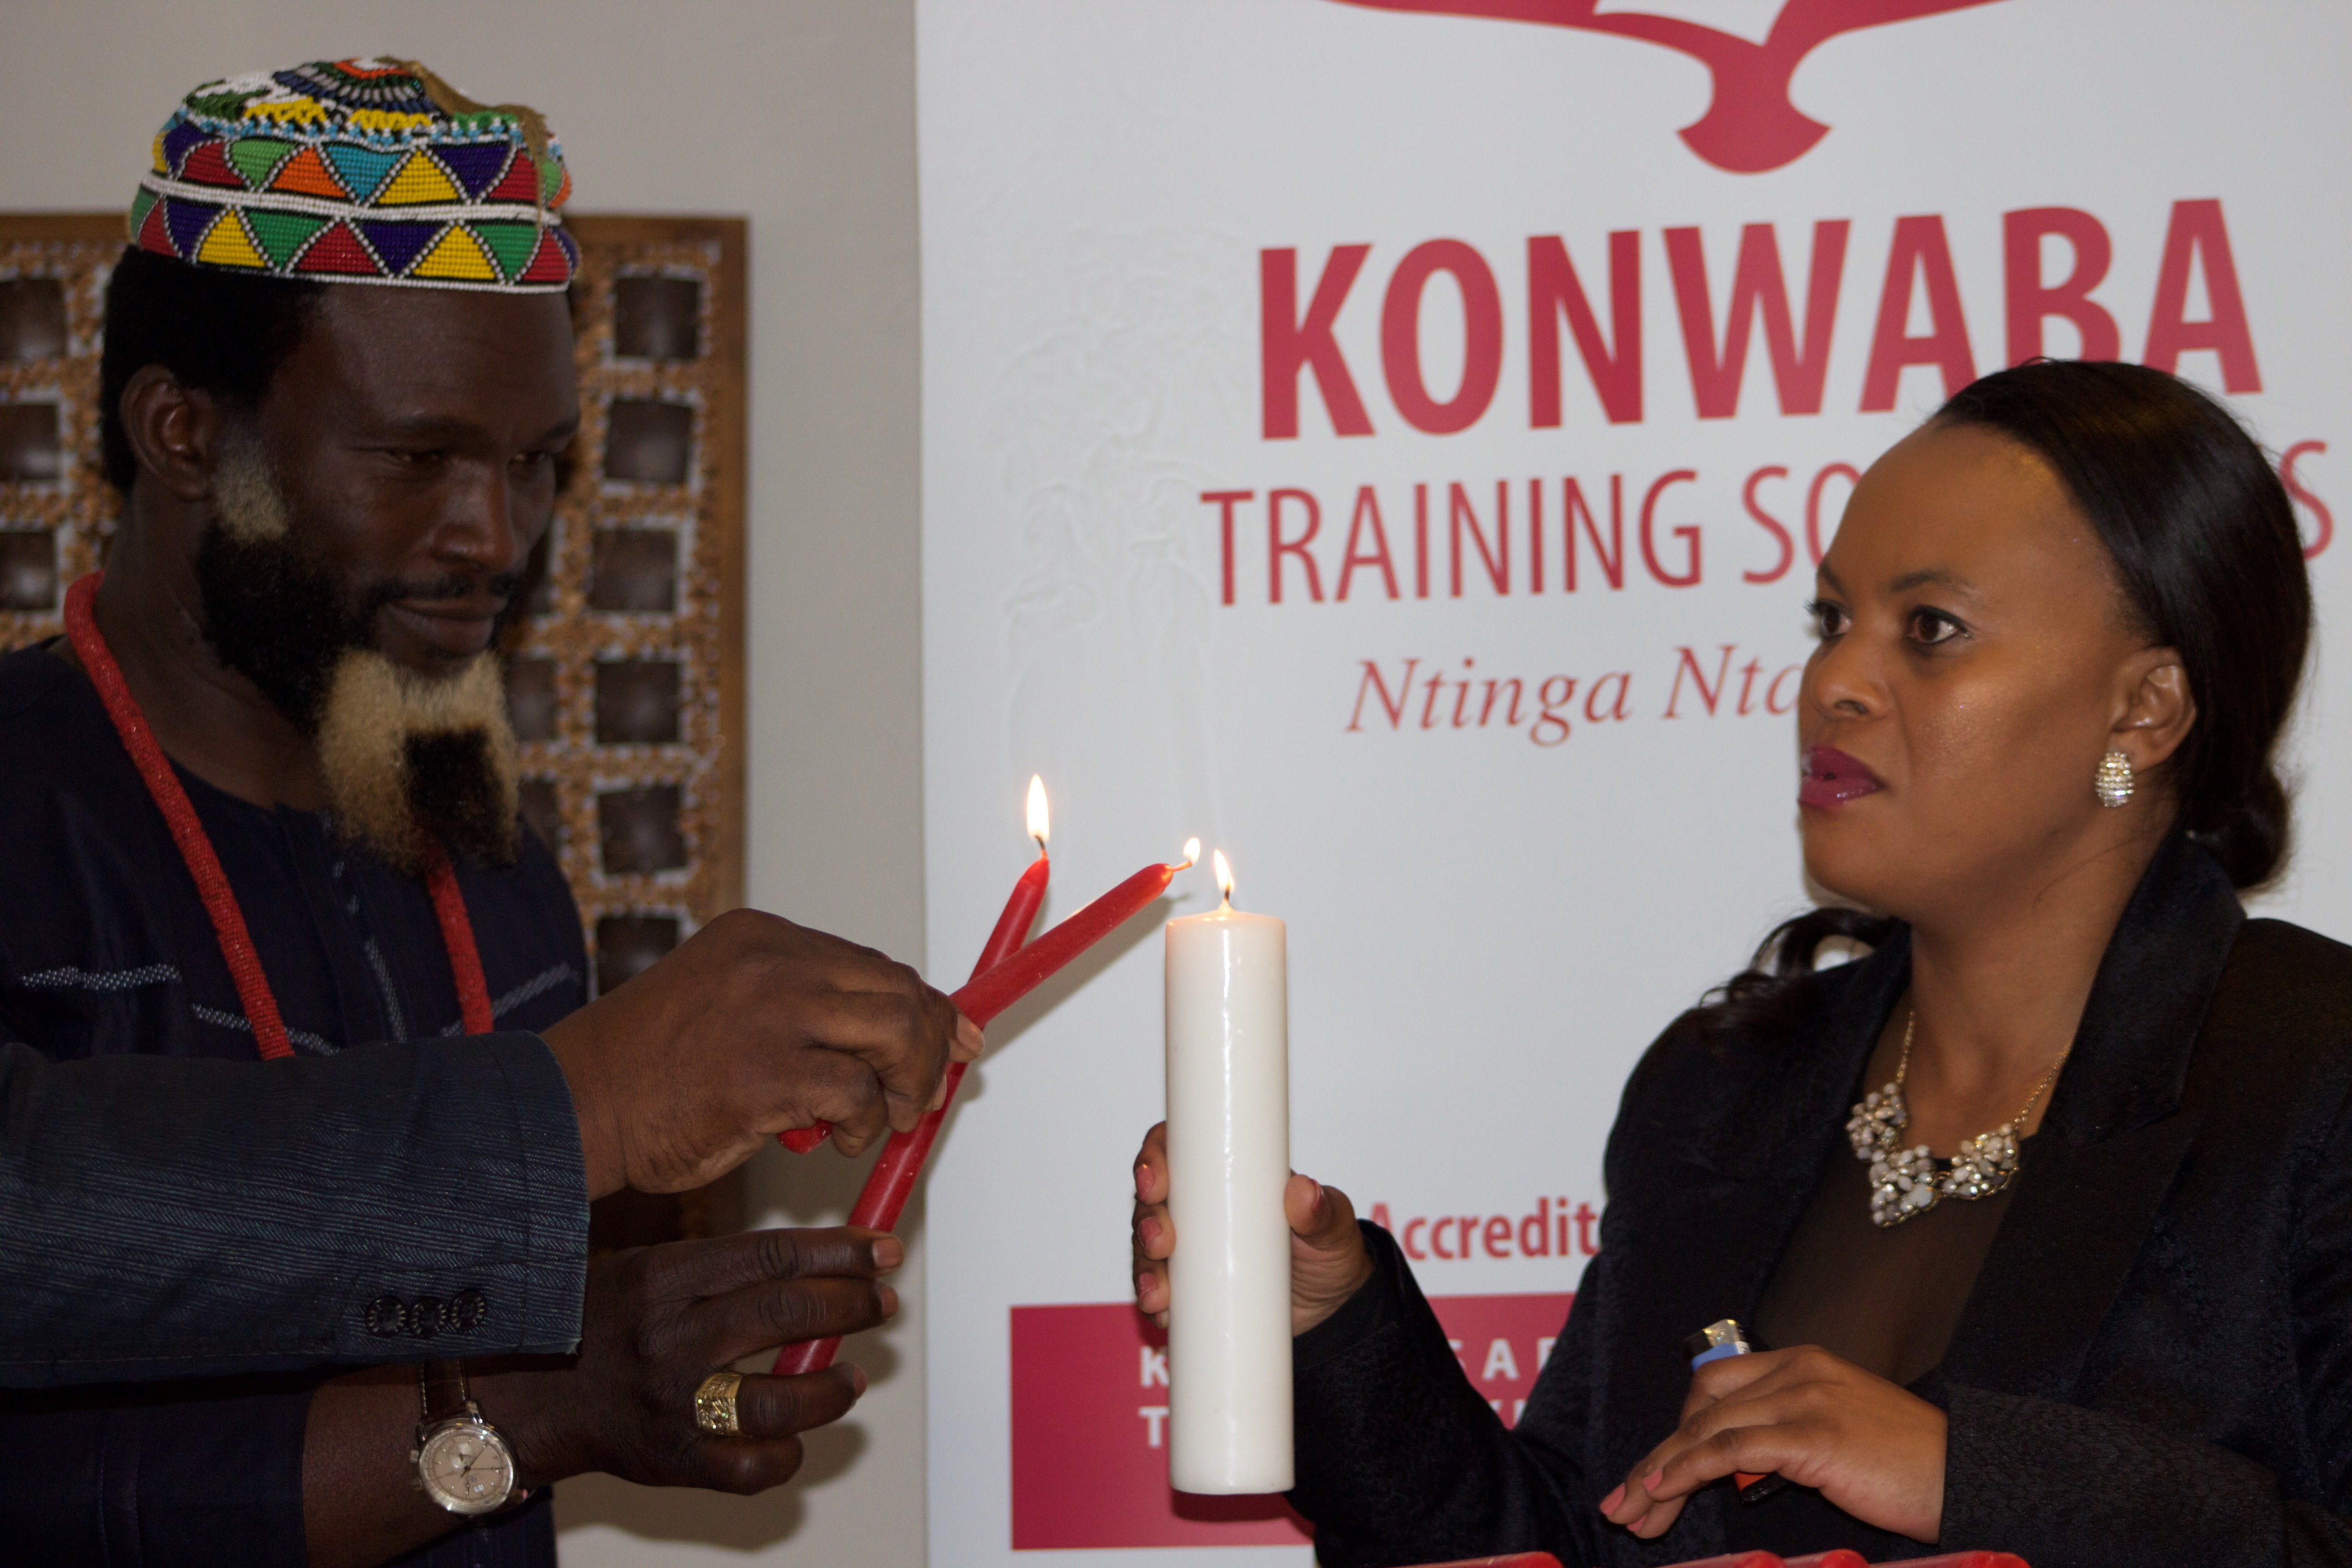
From left: Bishop Joshua Mapanga Human and Skills Consultant and Konwaba Training Solutions founder Nandipha Bhali
On Thursday the 19 November 2015 at the Regent Hotel in East London, saw the launch of a new dynamic training and development institution called Konwaba Training Solutions (KTS). Konwaba is aimed at assisting municipalities and Further Education & Training (FET) institutions around the Eastern Cape to implement their policy analysis and development programmes.
The guest speaker at the breakfast session Bishop Joshua Mapanga a Human and Skills Consultant emphasized that “a person should dream big, be innovative and act on your dream and don’t let anything or anyone stand in your way” congratulating as well as applauding Nandipha Bhali for going after her dreams and opening an avenue where other people will benefit and prosper.
KTS a vision of the Eastern Cape born and bred Bhali, a young black woman who is passionate about the empowerment and growth of the people of the province said “inspired by the dusty streets of Ibika township in Butterworth, which is characterized by unemployment, poverty and high crime rates, I have always wanted to be instrumental in developing my people and be a beacon of hope for my people”.
Konwaba Training Solutions (KTS) is a consultancy service that focuses on research, policy analysis & Development, organizational development and community development. They work with small & large organisations in the private, public and community sectors. Konwaba is a registered Closed Corporation (CC) and is a BEE 100% black Female –owned training institution. Their service offering includes:
- Organisational Consulting
- Inter-Agency Participation Facilitation
- Policy Review and Policy Impact Analysis
- Community Development
- Social and Organisation Research
KTS conducts its business in a manner that is socially responsible through its community & policy work which contributes to societal transformation. With Ubuntu as their guiding philosophy, the following key values inform and underpin their practice:
• Fairness
• Integrity
• Mutuality
• Social Responsibility
As part of their organisational consulting services they adopt a systemic approach to facilitate learning and development at an individual, group and organisational levels. KTS considers each client’s needs to be unique and tailors each intervention accordingly. It is their belief that it is through working collaboratively and in true partnership with a client that long term behavioral and systemic changes can be achieved.
Akhona Mayosi friend of Bhali and the Human Generalist Manager at the Technical Vocational Education Colleges in Limpopo shared that Bhali should not go in to test the waters but rather should go in to makes waves and concluded by saying, ”my friend Nandi you are an exceptional woman”
To conclude the auspicious occasion a candle light moment transpired between the guest speaker together with Bhali and other esteemed guests to give light to the new venture. For any queries about the event and the organization please contact Lundi Nomnganga at 078 462 6557/043 721 3314 or email at lundin@konwaba.co.za.
Ntinga Ntaka Ndini

